# 7Days/6Nights Turkey Express

(Valid For March – October 2020)

## DAY 1 ARRIVAL ISTANBUL - CANAKKALE (L/D)



[**:**](http://phoenixtour.org/wp-content/uploads/2013/12/233.png)

Upon arrival Istanbul, visit Roman Hippodrome where horse chariot aces and events were held. Proceed to visit the Blue Mosque-Sultan Ahmet Mosque. Then visit Topkapi Palace – the seat of the Ottoman Empire, after it shifted its capital from Bursa to Istanbul. It is today, a museum palace with a wide collection of Kitchen wares and Porcelains, Treasuries, Royal Antiques, Courtyards, Holy Relics etc. After lunch, we will

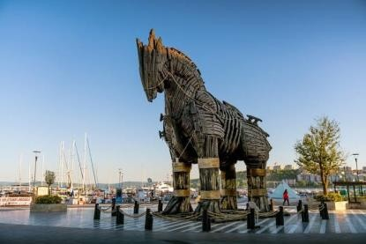begin our scenic drive down to Gallipoli, historically famous for being the site of many battles during WWI. Then we will cross the second strategic waterway, the Dardanelles, and land in Asia we will cross the second strategic waterway, the Dardanelles, and land in Asia. We will check-in to our hotel in Canakkale for dinner and overnight.

## DAY 2 : CANAKKALE - KUSADASI (B/L/D)

Following breakfast, we proceed to Troy. Referred to in Homer's "Iliad" and "Odyssey", Troy has in fact nine cities superimposed one

upon another. Troy VI pertains to the famous Trojan War of Homer where the legendary heroes included Agamemnon, Achilles, Ulysses, and Nestor on the Greek side and Priam, Hector, and Paris on the Trojan side. Depart for Kusadasi. Then visit Pergamon to see the Asklepion. The Asklepion in Pergamon was a healing temple in the Ancient Greece, as important as its counterparts in Epidaurus and Kos. Drive to Kusadasi. Visit Turkish Delight & Olive Oil Outlet center . Free time for shopping. Dinner and overnight in Kusadasi.

## DAY 3 : KUSADASI - PAMUKKALE (B/L/D)

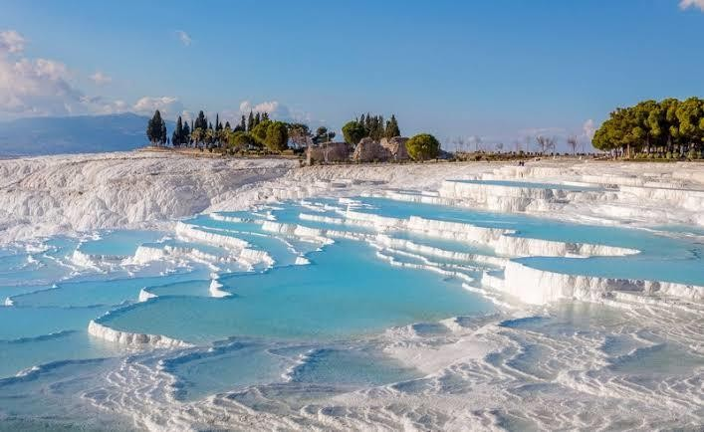Following breakfast, we drive to Selcuk to visit Ephesus as well as viewing one of the Seven Churches of Revelation, the Temple of Artemis (One of the Seven Wonders of Antiquity) and the Basilica of St. John from a distance, followed by lunch in the township of Selcuk. After lunch we will visit the famous local production center for leather garments whereby after a live Fashion Show time will be allocated for shopping. Drive to Pamukkale. Visit Pamukkale, where Calcareous hot springs descending over cliffs have created fascinating travertines in the form of white terrace and

basins Free time for walking on terraces. Tour the ruins of Ancient City Hierapolis. Enjoy Thermal Spa at hotel. Dinner and overnight at hotel in Pamukkale.

## DAY 4 : PAMUKKALE – KONYA - CAPPADOCIA (B/L/D)

Following an early breakfast, we will drive to Cappadocia. Lunch will be enroute before arriving in Konya. Konya was the center of the Seljuk Empire as well as the city of Mevlana and his Whirling Dervishes. After visiting the Mevlana Museum, we will continue to Cappadocia Cappadocia which is considered to be one of the natural wonders of the world with its surrealistic geological creation. Visit Oresin Caravanserai, an 13th century outstanding example of the Inns used by traders during the Silk Road. Dinner and overnight in Cappadocia.

## DAY 5 : CAPPADOCIA (B/L/D)

Today we visit one of the Underground City where early Christians lived secretly in order to survive and keep their faith. Picture stops will be given at the Valley of the Birds and at the foot of the Uchisar Castle.

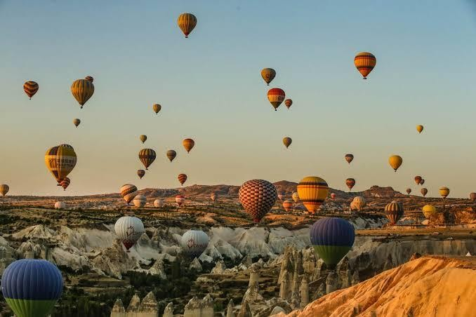Lunch will be at Avanos Village followed by the famous local pottery work shop . Then visit Dervent Valley Stop by local carpet weaving cooperative to see hand-made Turkish carpets. Dinner and overnight in Cappadocia.

## DAY 6 : CAPPADOCIA – ANKARA - BOLU (B/L/D)

Depart for Ankara, the capital of Turkey. Visit Salt Lake on the way. After lunch, visit the Ataturk Mausoleum – the final resting place of Mustafa Kemal Ataturk – Father of modern Turkey. The architecture of the mausoleum is a mix of different styles that represent the various Anatolian civilizations. Transfer to Bolu for dinner and overnight.

## DAY 7 : BOLU – DEPARTURE ISTANBU[L](http://phoenixtour.org/wp-content/uploads/2013/12/233.png) (B/L/D)

After breakfast at hotel, drive to Istanbul. Photo Stop at Sapanca Lake. Upon arrival have lunch in local restaurant. Then visit famous Grand Bazaar. The Grand Bazaar (or Covered Bazaar, Turkish: Kapalıçarşı) in Istanbul is one of the largest covered markets in the world with more than 58 streets and 4,000 shops, and has between 250,000 and 400,000 visitors daily. After dinner, transfer to airport.

## RATE PER PERSON IN USD

**(TWN/DBL/TRP)

|  |  |  |  |  |  |  |  |  |  |  |  |
| --- | --- | --- | --- | --- | --- | --- | --- | --- | --- | --- | --- |
| **(4* HOTEL) 1N CAN**  **Idakale 1N KUS**  **Ayma Beach 1N PAM**  **Tripolis 1N CAP**  **Alp Hotel 1N BOL**  **Soylu 1N IST**  **Golden Way** | **13 SEATER** | | | | **27 SEATER** | | | **45 SEATER** | | | |
| **2/3+0** | **4/5+0** | **6/7+0** | **8/9+0** | **10/14+0** | **15/19+1** | **20/24+1** | **25/29+1** | **30/34+1** | **35/39+1** | **40/44+1** |
| $1974 | $1163 | $887 | $724 | $632 | $403 | $291 | $260 | $235 | $220 | $209 |
| SINGLE SUPPLEMENT | $102 | | | | $82 | | | | | | |
| CHILD 6 – 12 AGE (WITH OR WITHOUT BED) | $184 | | | | $163 | | | | | | |
| CHILD 2 - 5 AGE (WITH OR  WITHOUT BED) | FREE | | | | | | | | | | |

**RATE INCLUDED:**

* 06 nights hotel accommodation with daily breakfast
* Meals as per program
* Indonesian speaking guide
* Transportation by modern A/C according to group size with free wi-fi internet
* Entry fees to the above mentioned sites
* 02 x 0,5 Small bottle of water per person per day
* 04 pax 01 Big bottle water sharing at the meals

**RATE EXCLUDED:**

* Drink with meals
* International and domestic flight tickets
* Tips for guide and driver after 15 pax :

(USD 3/day/perperson for Guide & USD 2/day/perperson for Driver)

* Tips for guide and driver 10 pax :

(USD 5/day/perperson for Guide & USD 3/day/perperson for Driver)

* Visa, Travel Insurance and Porter Fee
* Personal expenses
* Any other services not mentioned

**IMPORTANT NOTES:**

* Unavoidable changes in itinerary might occur due to climate change or governmental policies or exceptional events
* No reservation has been made in advance, hotels and rates are subject of changes depending on availability request
* The rates not available during Black-out dates/public holiday
* If they cancel to compulsory shopping on the spot, It will charge to 50 USD per person each shop. Responsibility is on the travel agents.